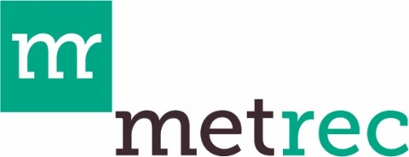

Gunnison County Metropolitan Recreation District

Grant Period Extension Request

Overview: MetRec seeks to support its partners in the successful planning and execution of recreation programs and projects. It is understood that unforeseen circumstances can interfere with planned timelines. For that reason, MetRec will consider requests for extensions to the Grant Period set forth in the Funding Agreement between Grantee and MetRec. Requests will be considered for approval by MetRec’s Board of Directors. If approved, a signed copy of this document will serve as an addendum to the original Funding Agreement and be shared with the grantee.

Instructions: If you wish to request an extension for your Funding Agreement, please complete this form and provide material for question 3 (if applicable) as a separate document. Once complete, submit via email to admin@gcmetrec.com

Organization Name (Grantee):
Grant Project Title:
Grant Amount:
Name and Title:
Mailing Address:
Phone:
E-mail:
Grant Period Start Date (as stated in the Funding Agreement):
Grant Period End Date (as stated in the Funding Agreement):
New Grant Period End Date (requested):

- Provide a brief overview explaining why the original program/project timeline has changed and an overview of the new program/project timeline (Max 5 sentences).

- If you have requested a Funding Agreement extension for this program/project already, please describe when and how long of an extension you were granted (Max 3 sentences).

- If the program/project budget has changed, provide a brief overview of how (Max 5 sentences) and include an updated itemized budget that reflects any changes to the original itemized expenditures.

Submitted by:

[GRANTEE'S NAME]
By:
Name:
Title:
Date:

Approved by:

MetRec Board Chair Date

