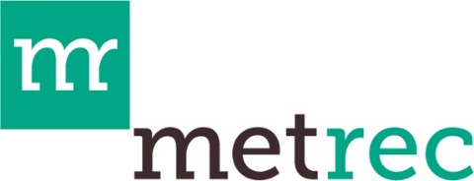

Gunnison County Metropolitan Recreation District

Grant Project Completion Report Form

Instructions: Please complete this form following execution of the Funding Agreement by the District and submit via email to admin@gcmetrec.com. For Multi-Year Projects, this form must be completed each year until the Grants are completed. All undefined, capitalized terms used in this Request for Payment shall have the meanings ascribed to them in the Funding Agreement between the District and Grantee.

Organization Name (Grantee):
Grant Project Title:
Grant Amount:
Actual Grant Funds Expended:
Name and title:
Mailing Address:
Phone:
E-mail:
Grant Period Start Date:
Grant Period End Date:

- Which grant program were you awarded funds from?
☐ Capital
☐ Nonprofit Operations Support
☐ Community Collaboration
☐ Multi-year Nonprofit Operations Support
☐ Multi-year Community Collaboration

- Grant Project Description (Max 5 sentences):

- Briefly describe the community impact of your project and program (Max 5 sentences):

- How did you choose to acknowledge MetRec grant funding (as required by the Funding Agreement)? Please attach evidence of acknowledgement(s) that includes the date given.

- Please provide the following information regarding expenditures and invoices for the completed Grant Project:

- An itemized statement for actual expenditures on the Grant Project paid for by Grantee with grant funds.

- Copies of paid invoices for materials received and labor and services performed on the Grant Project and paid for by Grantee with grant funds.

- 3-5 photos of the project or program as original file type, size, and resolution.

- By signing below, Grantee represents and warrants to the District that the Grant Project is complete and that all amounts due and payable for the Grant Project have been paid. The Grantee also represents and warrants that all work done on the Project was completed in a good and workmanlike manner and in accordance with the Funding Agreement and Approved Grant Application.

[GRANTEE'S NAME]

By:
Name:
Title:
Date:

